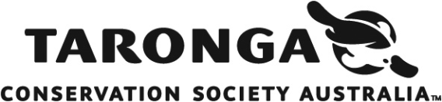

Taronga Field Conservation Grants
Application Instructions

Projects must meet all principles below. If any principle cannot be met, applicants should reconsider submitting.

1. Measurable conservation outcomes: Projects must deliver clear, measurable benefits for species and/or habitats. Education components are welcome, but outcomes must be ecological rather than community impact alone.
2. Alignment with IUCN Sustainable Development Goals (SDGs): Projects must align with relevant SDGs.
3. In situ focus: Projects do not need ex situ breeding or zoo-held species components to be successful.
4. Translocations/reintroductions: Where applicable, projects must be endorsed by relevant authorities and comply with IUCN, CITES and IATA requirements (evidence required).
5. Animal welfare: Humane treatment of animals is mandatory; captive components (if any) must meet ZAA (Zoo and Aquarium Association Australasia) standards.
6. Risk: Projects must not pose unreasonable safety, financial or reputational risk.
7. Funding period: January 2027 – December 2028, with reporting at 12 months and project completion.
8. Legal compliance: All activities must comply with national and local laws.
9. Eligibility: Organisations must have no convictions relating to fraud, corruption, wildlife trade or animal cruelty (declaration required).
10. Sanctions: Organisations in DFAT (Department of Foreign Affairs and Trading) sanctioned countries may be ineligible for funding.

Selection Criteria:
- Clear and defined SMART goals and conservation benefits.
- Demonstrated alignment to relevant UN Sustainable Development Goals.
- Consideration of 360 degree approach to conservation, connecting wildlife, habitat and communities.
- Clear modular budget (using template provided) that aligns with project goals within the defined period of funding.

Project Summary:
- Project title
- Name of project leader & organization
- Primary email for the submission
- Organisation status

Total Project Budget

Project Overview (3200 character limit)
Briefly outline;
• Conservation problem or threat
• Target species/habitat and location
• Proposed actions
• Expected conservation impact

Project Details
The following questions are based on the specific criteria that will be used to assess each project.

Objectives & Smart Goals
Detail your project's objectives and the strategies for achieving them, using SMART (Specific, Measurable, Achievable, Relevant, Time-bound) goals.

If successful, recipients will report against these goals. For each goal, specify:
· What will change?
· By how much?
· By when?

Measurable Conservation Outcomes
Describe the specific ecological outcomes expected.

Identify:
· The key threatening process addressed
· How outcomes will be measured (indicators and methods)

Project Design and Logic
Explain how proposed activities will lead to the stated outcomes.

Briefly address:
· Link between actions, threats and outcomes
· Climate change considerations (if relevant)
· Social, cultural or governance context

IUCN Sustainable Development Goals (max 4)
Select from list in online application.
Link to goals can be found here: https://iucn.org/our-work/informing-policy/international-policy/un-sustainable-development-goals

Partners and capability
Briefly note relevant experience of project leader and organisation to undertake this work.

Urgency and consequence of inaction
Explain the potential consequences of the project not going ahead

Longevity and sustainability
Include:
· Ongoing management or funding needs
· Capacity building of local stakeholders

Local engagement and governance
Describe how the project is embedded locally.
Include:
• Involvement of local communities and authorities
• Permits, approvals or endorsements (if applicable)

Budget
Please use the below template for your budget.
All funds should be requested in Australian (AUD) dollars.
Funds are paid as a lump sum at project commencement

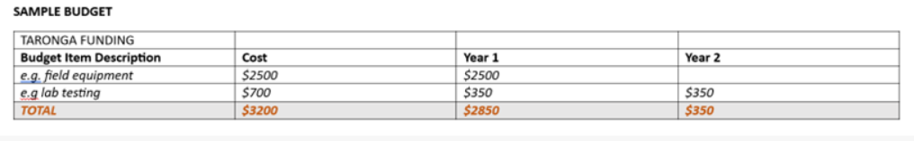

If successful, please provide details of how the support of the Taronga Foundation would be acknowledged.

Supporting Information

Option to include CV of project lead (max 2 pages), letters of support or collaboration and relevant permits or approvals (if applicable)
Additional information is not necessary but may be provided to support your application, including:
a) Curriculum vitae of project leader (maximum of 2 pages)
b) Letters of reference, recommendation and collaboration
c) Copies of permits (if applicable)

Review process and timeline

· Applications reviewed by the Taronga Conservation Committee
· Submission deadline: Midnight, April 26th 2026 (AEST)
· Review panels convened by mid-September
· Outcomes advised by October

Due to application volume, only successful applicants will be notified.
Questions can be sent to fieldgrants@zoo.nsw.gov.au.
Definitions for Terms in Field Project Criteria

Conservation outcomes: outcomes that directly benefit the conservation status of a species or ecosystem, ie. protection of habitat; increased protection of the target/focal species. Activities such as education, research or planning may contribute to achieving conservation outcomes, but are not conservation outcomes themselves. It is very important that the outcomes are measurable in ecological terms.

Conservation benefits: positive impacts on wildlife, ecosystems, or natural resources, resulting from actions aimed at preserving, protecting, or restoring the natural environment and wildlife populations e.g increased biodiversity, habitat restoration, species recovery, sustainable practices.
Ecosystem: a community of organisms, the environment within which they live and interact, and their interactions (ie. decomposition, nutrient release, etc.).

In situ wildlife conservation: in the field, as distinct from in captivity. Usually also relates to activity within the range or future range of the focal/target species.

Threatening processes: processes or activities that threaten wildlife, habitats or ecosystems, e.g. habitat loss, climate change, hunting/poaching, introduced species, pollution and identified diseases.

